Submitted to the US House Committee on Ways and Means
Subcommittee on Work and Welfare
Hearing on “Welfare Reform at 30: Restoring the Promise of Work and
Personal Responsibility in Federal Welfare Programs”

Welfare Reform at 30: Major Effects and Lessons for Additional Reform

Matt Weidinger
Senior Fellow and Rowe Scholar

September 1, 2026

Chairman LaHood, Ranking Member Davis, and members of the Subcommittee on Work and Welfare, thank you for holding this hearing on the 30th anniversary of the 1996 welfare reform law and allowing me to submit this written testimony.

My name is Matt Weidinger, and I am a Rowe Scholar in the Center for Opportunity and Social Mobility at the American Enterprise Institute (AEI). Before joining AEI, I served for over two decades on the staff of the House Committee on Ways and Means, including as a professional staff member of what was then known as the Subcommittee on Human Resources during the development, passage, and early implementation of the 1996 welfare reform law. I was honored to play a small role in that process and to later serve as staff director of this subcommittee and finally as deputy staff director of the full committee. My testimony reviews some of the remarkable history behind and results of the 1996 welfare reform law and concludes with suggestions for improving the effectiveness of our nation’s safety net in helping low-income families prosper.

The Remarkable Bipartisan Process Behind the 1996 Law

The Ways and Means Committee, then led by Chairman Bill Archer (R-TX) and Human Resources Subcommittee Chairman Clay Shaw (R-FL), played a leading role in crafting the 1996 welfare reform law. They led a process that embodied a legislative textbook for how to craft major reforms, starting with extensive deliberation and regular order in committee.

The early stages in the development of that law, summarized in the committee’s legislative activity report for the 104th Congress, are a remarkable testament. During just the first two weeks of January 1995, the full committee conducted four hearings that reviewed policies in Republicans’ Contract with America legislative agenda, including its welfare reform proposals, which were reflected in H.R. 4. The Subcommittee on Human Resources then conducted eight hearings on specific welfare reform policies and proposals over several weeks through early February. Witnesses included governors, administration officials, policy experts, and everyday Americans. Then, in a practice long since abandoned, the subcommittee marked up legislation over three days in mid-February, sending it to the full committee for consideration. The full committee followed suit, approving the legislation in mid-March before the House passed an amended version on March 24, 1995.

The Senate approved its own bill in September, and formal conference committee deliberation followed, producing two versions of the massive legislation. One was included in the Balanced Budget Act, which President Bill Clinton voted in December 1995. The second advanced as H.R. 4, a freestanding welfare reform bill that the president vetoed in January 1996.

The legislative process then started again, aided by the nation’s governors and the welfare reform plan President Clinton offered in his budget proposal. Once again, hearings were followed by both subcommittee and full committee markups before the comprehensive legislation advanced to the Budget Committee, which was assembling a welfare reform reconciliation measure. Separate House and Senate versions of the legislation were approved, followed by a brief conference committee and final approval of the compromise conference report in each body.

Large bipartisan majorities (328–101 in the House and 78–21 in the Senate, both greater than the majorities behind the creation of Medicare and Medicaid in 1965) approved the final welfare reform legislation. Republicans provided nearly unanimous support, while half of Democrats in the House and a majority of Democrats in the Senate, including Senator Joe Biden (D-DE), supported the legislation. Both of the current committee members who served in the 104th Congress, Ranking Member Richard Neal (D-MA) and Health Subcommittee Ranking Member Representative Lloyd Doggett (D-TX), voted for the conference report that became the welfare reform law.

After two prior vetoes, President Clinton signed this third welfare reform measure, the Personal Responsibility and Work Opportunity Reconciliation Act, into law on August 22, 1996, with senior committee members Clay Shaw and Sander Levin (D-MI) in attendance at the Rose Garden signing ceremony.

Major Effects of the 1996 Law

That welfare reform legislation was one of the signature events in American social policy history. The landmark law was notable for the remarkable scope of its reforms. In the first ending of a major New Deal program, it replaced the nation’s most prominent cash welfare program, Aid to Families with Dependent Children (AFDC), with the new Temporary Assistance for Needy Families (TANF) program. The new law replaced the former federal individual entitlement to AFDC welfare checks with fixed block grants to states, expanded “work supports” like childcare that promoted earnings instead of dependence on benefits, and expected states to engage able-bodied adults in work or training. The legislation set time limits on TANF assistance, increased child support payments to custodial parents, and achieved significant savings for taxpayers by reforming disability benefits and curtailing welfare eligibility for noncitizens, among other major reforms.

While that’s an impressive list of reforms, the actual effects of the law—especially in promoting more work and earnings and less poverty and welfare dependence—exceeded what even some of the legislation’s strongest advocates anticipated, as shown below.

Sharp Rise in Work and Earnings

As shown in Figure 1, as the 1996 law was crafted and implemented, the US witnessed an unprecedented surge in work participation among never-married single mothers—the group most likely to depend on welfare checks. As Robert Moffitt and Stephanie Garlow noted in a 2018 review, “In the initial years after reform, many more women joined the labor force than even the reform’s most ardent supporters had hoped.”

Figure 1. Labor Force Participation Rate for Selected Groups of Women, Age 18–54,
1990–2024
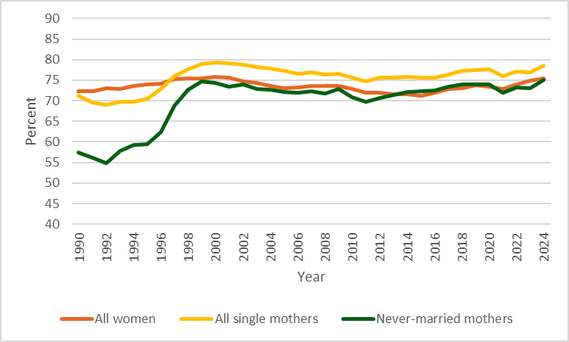
Source: Author’s calculations from US Census Bureau and US Bureau of Labor Statistics Current Population Survey data at https://cps.ipums.org/cps/sda.shtml.

According to Ron Haskins, who was the staff director of the Human Resources Subcommittee as the 1996 law was being drafted and later a scholar at the Brookings Institution, “employment among these most disadvantaged mothers increased almost 40 percent over the four-year period beginning in 1996.” The mean wage and salary income of never-married mothers also rose sharply after the 1996 reforms and, as displayed in Figure 2, has now doubled pre-reform levels, in real terms.

Figure 2. Mean Wage and Salary Income for Married and Never-Married Mothers,
Age 18–54, 1990–2024
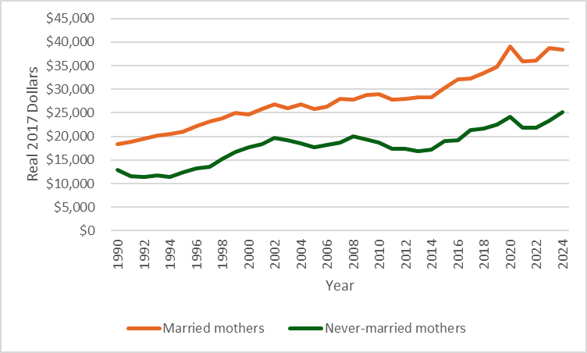
Source: Author’s calculations from US Census Bureau and US Bureau of Labor Statistics Current Population Survey data at https://cps.ipums.org/cps/sda.shtml.

Some studies attributed a significant share of growing work and income in the late 1990s to the separate 1993 expansion of the Earned Income Tax Credit (EITC) or even the strong economy. However, more recent reviews have focused more credit on the welfare reform law. For example, a January 2026 study by Adam Looney of the Brookings Institution found that “welfare reform, rather than the EITC expansion, drove the employment gains of the 1990s.” As displayed in Figures 1 and 2, the work and earnings gains following the 1996 reforms endured well beyond the 1990s, including through subsequent recessions.

Large Reductions in Poverty

As household incomes swelled due to more work and earnings, poverty fell sharply—instead of rising as reform opponents dramatically foretold. Senator Daniel Moynihan (D-NY) predicted children “sleeping on grates”—a dystopian “Grate Society,” as it were. Future Speaker of the House Nancy Pelosi (D-CA) ventured, “The Republican welfare reform proposal will make the problems of poverty and dependence much worse because it refuses to make work the cornerstone of welfare reform.” Jill Nelson of The Nation forecast “massive and deadly poverty, sickness and all manner of violence. People will die, businesses will close, infant mortality will soar. . . . Working- and middle-class communities all over America will become scary, violent wastelands.”

Fortunately, they were all wrong. Figure 3 compares child poverty rates under the official poverty measure (OPM), which counts earnings and welfare checks, among other income, and the supplemental poverty measure (SPM), which adds in-kind benefits like food stamps and tax

Figure 3. Child Poverty Rates under the OPM and SPM, 1990–2024
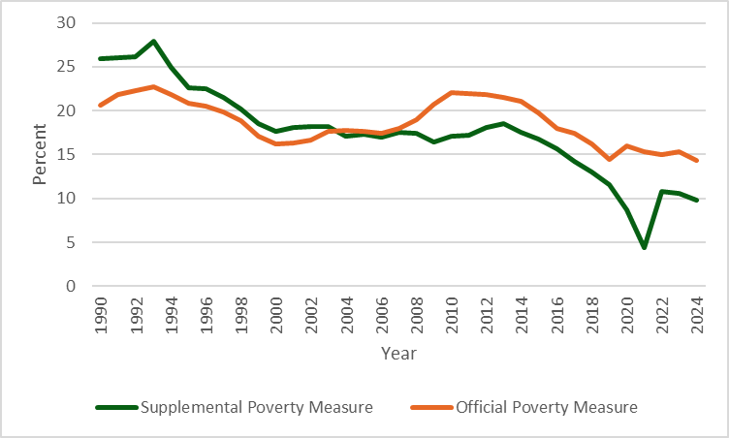
Source: US Census Bureau, Historical Poverty Tables, “Table 3. Poverty Status of People and Distribution of the Poor by Age, Race, and Hispanic Origin,” https://www.census.gov/data/tables/time-series/demo/income-poverty/historical-poverty-people.html; and Columbia University, Center on Poverty and Social Policy, Historical Supplemental Poverty Measure Data, https://povertycenter.columbia.edu/historical-spm-data.
Note: The SPM is anchored to 2012 living standards and adjusted using the consumer price index. Income data are not adjusted for underreporting.

payments such as the EITC, under a more relative measure. Under both measures, overall child poverty fell sharply in the late 1990s and, especially under the SPM that includes growing tax and in-kind benefits payable to low-income working parents, notable progress continued in the decades following.

For key groups, post-reform results were even more encouraging. For example, the rate and number of African American children in poverty reached record lows in 2001. By 2002, even The New York Times admitted, “Welfare reform has been an obvious success.”

Unprecedented Welfare Caseload Declines

The 1996 reforms resulted in an unprecedented decline in the number of adults collecting welfare checks, from 4.38 million adult AFDC recipients in fiscal year (FY) 1995 to 1.30 million adult TANF recipients in FY 2002 and just 579,000 in FY 2025. Overall, the AFDC/TANF caseload has declined by 85 percent since reform. Figure 4 displays these enormous caseload declines in terms of individuals and families receiving AFDC/TANF assistance since 1960. Even the Great Recession and COVID-19 pandemic barely altered the steady decline in the cash welfare caseload since the mid-1990s.

Figure 4. AFDC/TANF Caseload in Families and Recipients, FY 1960–2025
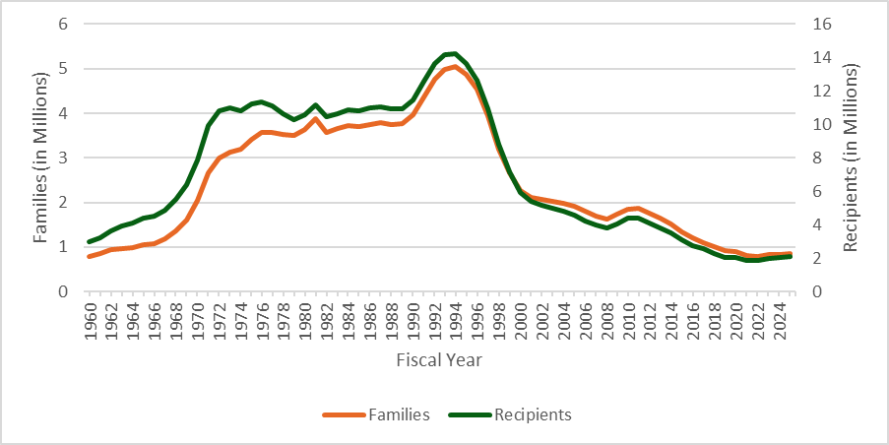
Source: US Department of Health and Human Services, Administration for Children and Families, Office of Family Assistance, “AFDC Caseload Data 1960–1995,” January 25, 2021, https://acf.gov/archive/ofa/data/afdc-caseload-data-1960-1995; and US Department of Health and Human Services, Administration for Children and Families, Office of Family Assistance, “TANF Caseload Data,” 1996–2025, https://acf.gov/ofa/resource-library?f%5B0%5D=program%3A270&f%5B1%5D=program_topic%3A634.

Surging Federal Funds Available to Assist Families on Benefits

Combined with the fixed federal TANF block grant, large caseload declines meant that federal funding available to states per family receiving welfare checks rose dramatically, from $3,500 in 1995 to nearly $20,000 in 2024—almost triple the 1995 level in real terms. As I reviewed in 2024 committee testimony, for some states with even steeper caseload declines, the increases in available federal funds per remaining recipient were even greater.

Despite those steep caseload declines, states continued to receive the same amount of federal TANF funding as in the late 1990s—albeit without an inflation adjustment. Nonetheless, the current block grant has proven more than adequate, with the US Department of Health and Human Services (HHS) reporting that, at the start of FY 2025, states collectively had $11.3 billion in unspent federal TANF funds, with every state except New Jersey reporting reserve funds.

Significant Savings for Taxpayers

At the time of its passage, the Congressional Budget Office estimated the 1996 welfare reform law would save $54 billion through 2002, with about $5 billion of those savings attributable to the fixed TANF block grants not matching previously expected growth in federal AFDC spending.

Compared with the cost of adjusting the TANF block grant for inflation, taxpayers have received an estimated $180 billion in real savings over the 1997–2024 period. Even those large savings may be an understatement, as means-tested programs like TANF rarely grow at just the rate of inflation. For example, since FY 1997, food stamp spending (under what is now called the Supplemental Nutrition Assistance Program) more than doubled in real terms, from $41.9 billion (in current dollars) in 1997 to $100.3 billion in 2024.

Major Improvements in Addressing Waste, Fraud, and Abuse

Beyond TANF, other significant 1996 reforms ended payments to groups that never should have been on public assistance.

The welfare reform law curtailed noncitizen eligibility for Supplemental Security Income (SSI), a welfare program for disabled and elderly individuals. In the decade before reform, noncitizen SSI receipt had more than tripled. Most recipients had pledged not to collect welfare as a condition of entry into the United States, and seniors received limitless SSI pension checks despite often performing little or no work after arrival. Current recipients ended up being grandfathered, but today, noncitizen receipt of SSI is down nearly 60 percent from its pre-reform peak.

Prisoners similarly didn’t belong on disability benefits, but pre-reform rules expected inmates to notify authorities of their change of address to a prison for their benefits to end. Few did. In response, reformers provided incentive payments to jails reporting inmate rosters so SSI checks would stop flowing.

Separate reforms, initially included in H.R. 4 but enacted as part of the Contract with America Advancement Act of 1996, ended drug addiction and alcoholism as qualifying conditions for SSI disability checks, while providing more funds for treatment.

Continued Bipartisan Support for Reauthorizing TANF

The result of those reforms—more work and earnings among never-married female-headed households and less poverty, welfare dependence, and misspending—have contributed to the remarkable durability of the 1996 reforms, especially regarding TANF policy. The lawmakers who designed the 1996 law intentionally made the authorization of the new TANF program time-limited (initially through FY 2002) to force subsequent congresses to evaluate the reforms and make appropriate adjustments. However, only one major reauthorization bill has been enacted: the five-year reauthorization included in the Deficit Reduction Act of 2005, which provided only modest changes to the TANF program. Among other reforms, that legislation updated the baseline year for calculating caseload reduction credits toward TANF work participation requirements, established healthy marriage promotion grants and responsible fatherhood initiatives, and increased childcare funding by $200 million per year, offset by other savings.

The years since that five-year reauthorization legislation expired in 2010 have been marked by a steady series of short-term extensions of current law. The only significant exception was the Fiscal Responsibility Act of 2023, which attempted to address certain loopholes states have exploited to avoid engaging more able-bodied adults in TANF work activities. Those short-term reauthorization bills were almost always approved on a broad bipartisan basis. In all, more than 50 short-term TANF extensions have been enacted, often as part of broader continuing appropriations legislation.

It is noteworthy that, even when Congress fails to agree on short-term extension legislation, as it did in fall 2025 during the federal government shutdown, the design of the TANF program—in particular its shared state funding and large federal reserves—insulates recipients from government shutdown effects. While the 2025 government shutdown suspended regular food stamp payments to 42 million individuals, states were able to continue paying full TANF benefits as scheduled.

Enduring Popularity of Work-Based Reforms

Now, 30 years later, polling indicates that Americans continue to strongly support the 1996 law’s cornerstone principle of expecting welfare recipients to work or participate in work-related activities in exchange for benefits. For example, in 2023 a YouGov poll found that two-thirds of all Americans—including 64 percent of Democrats—agreed with that sentiment. The same year, a Wisconsin ballot measure found almost 80 percent of voters supported expecting able-bodied, childless adults to look for work to collect taxpayer-funded welfare benefits. A 2026 poll conducted by AEI’s Survey Center on American Life found that 75 percent of respondents supported requiring able-bodied adults to work or search for work in exchange for welfare benefits; only 22 percent opposed that requirement.

That broad and ongoing support for work requirements informed the authors of 2025’s One Big Beautiful Bill Act, which significantly expanded the number of able-bodied adults expected to work, train, or perform community service on at least a part-time basis to qualify for Medicaid and food stamp benefits. An HHS report suggests the requirements could significantly increase work and earnings while reducing poverty and benefit dependence. If so, that would match the results of historic reforms applied to largely work-free AFDC checks a generation ago. As those expanded work requirements are implemented, they have a built-in advantage—broad support from the American public, which continues to believe that recipients of means-tested benefits should work or prepare for work to qualify.

Changes to Strengthen the 1996 Reforms

For all the important gains and popular support for work-based welfare reforms, additional changes are needed to ensure that promoting work remains central to the mission of not only TANF but the balance of the safety net.

Changes Needed to Strengthen and Refocus TANF

A recent HHS report finds that, due to several gimmicks and policy loopholes, effective TANF work requirements are currently vanishingly small. In FY 2024, only 8 percent of TANF families included an adult working enough to count toward the program’s work requirements. One reason for that absence of work is the growing share of households headed by an illegal alien adult. Current law allows illegal alien parents to receive welfare checks on behalf of their citizen children while avoiding program work requirements and time limits that apply to citizen-headed households. While Congress took some modest steps to reduce especially the former loopholes in 2023, more work remains to be done.

Reductions in TANF Dependence Have Been More Than Offset by Growth in Other Programs

As TANF was converted from an open-ended entitlement into a fixed block grant, remaining open-ended federal entitlements like food stamps, Medicaid, several refundable tax credit programs, and recent welfare-like unemployment check expansions exploded in both spending and number of recipients. For example, as displayed in Figure 5, the number of individuals receiving food stamp benefits grew from 26.6 million in 1995 to 42.4 million in 2025. While those totals include childless adults, overall growth in the food stamp and Medicaid caseloads far exceeds the decline in AFDC/TANF recipients over the same period.

Meanwhile, other benefits targeting low-income families with children, like the EITC, first enacted in 1975, and the Child Tax Credit (CTC), created in 1997, also saw significant growth. Major new welfare-like unemployment benefits—supported by general revenues instead of payroll taxes and paid without confirming prior earnings to individuals who may not have previously worked—also were paid to millions of new recipients during the pandemic. Senior lawmakers have called for reviving those programs and making them permanent, without offering any sense of how they would pay for the expansions.

Figure 5. Individuals Receiving Key Means-Tested Benefits, FY 1995 and 2025
Program | 1995 | 2025 | Change
AFDC/TANF | 13.7 million | 2.1 million | − 85 percent
Food Stamps | 26.6 million | 42.4 million | + 59 percent
Medicaid/CHIP | 36.3 million | 78.0 million | + 115 percent
Source: US Department of Health and Human Services, Administration for Children and Families, Office of Family Assistance, “Caseload Data 1995 (AFDC Total),” July 31, 2023, https://acf.gov/archive/ofa/data/caseload-data-1995-afdc-total; US Department of Health and Human Services, Administration for Children and Families, Office of Family Assistance, “TANF Caseload Data 2025,” February 6, 2026, https://acf.gov/ofa/data/tanf-caseload-data-2025; US Department of Agriculture, Food and Nutrition Service, “Supplemental Nutrition Assistance Program Participation and Costs,” June 12, 2026, https://fns-prod.azureedge.us/sites/default/files/resource-files/snap-annualsummary-6.pdf; US House Committee on Ways and Means, 1998 Green Book: Background Material and Data on Programs Within the Jurisdiction of the Committee on Ways and Means, May 19, 1998, table 15-14, https://aspe.hhs.gov/sites/default/files/private/aspe-files/210946/15other.txt; and Medicaid and CHIP Payment and Access Commission, “MACPAC Releases Latest Edition of MACStats: Medicaid and CHIP Data Book,” press release, February 5, 2026, https://www.macpac.gov/news/macpac-releases-latest-edition-of-macstats-medicaid-and-chip-data-book/.
Note: The Children’s Health Insurance Program (CHIP) was created in 1997. The 2025 value for Medicaid/CHIP reflects July 2025.

Even before massive pandemic increases, federal spending on children in programs primarily serving low-income populations increased nearly fourfold in real terms between 1990 and 2019. Some of the subsequent growth resulted from liberal policy expansions specifically designed to thwart the pro-work lessons of the 1996 law. For example, here’s how one journalist characterized 2021’s massive expansion of the CTC, in an American Prospect article titled “Undoing Welfare Reform”:

Most notably, the legislation included an expanded Child Tax Credit. . . . The expansion didn’t merely increase the benefit to as much as $3,600 per child; it also expanded eligibility to families with little or even no earnings. Passage of a universal child allowance finally reversed a 25-year trajectory of welfare reform.

That temporary CTC expansion subsequently expired. But leading Democrats have called for reviving and making permanent the 2021 CTC expansion.

A New Generation of Reforms

After years of failed attempts to extend the lessons of the 1996 law to other programs, some major reforms inspired by the law are now being implemented. Most notably, the 2025 One Big Beautiful Bill Act is taking significant steps toward increasing work and reducing welfare dependence and fraud by strengthening work requirements for food stamps and Medicaid. It also holds states financially accountable for high food stamp error rates. Meanwhile, the Trump administration recently proposed allowing local public housing agencies to apply work requirements and time limits to housing assistance.

Lawmakers should expand those reforms by further strengthening work incentives, applying time limits to reduce dependence, and holding states financially accountable for achieving better outcomes. They should also consolidate more of today’s 90-plus welfare programs so they are easier to administer and for those in need to navigate.

Those and other reforms inspired by the 1996 reform law would promote more work, greater personal responsibility and accountability, and less fraud and abuse in welfare programs. At the same time, lawmakers should continue to resist calls to revive work-free welfare benefits, whether in the form of expanded child tax credit payments, various unemployment benefits, or
universal basic income checks.

Report on the Activities of the Committee on Ways and Means, H.R. Rep. No. 104-872 (1996), https://www.congress.gov/committee-report/104th-congress/house-report/872.
Personal Responsibility and Work Opportunity Reconciliation Act of 1996, Pub. L. No. 104-193.
Matt Weidinger and Angela Rachidi, “The White House Defender of Welfare Work Requirements,” AEIdeas, May 23, 2023, https://www.aei.org/opportunity-social-mobility/the-white-house-defender-of-welfare-work-requirements/.
US House Committee on Ways and Means, Summary of Welfare Reforms Made by Public Law 104-193, the Personal Responsibility and Work Opportunity Reconciliation Act, and Associated Legislation, November 6, 1996, https://www.govinfo.gov/content/pkg/CPRT-104WPRT27305/pdf/CPRT-104WPRT27305.pdf.
Matt Weidinger, “Less Activation in US Social Assistance Programs?,” in Work and the Social Safety Net: Labor Activation in Europe and the United States, ed. Douglas J. Besharov and Douglas M. Call (Oxford University Press, 2023).
Robert A. Moffitt and Stephanie Garlow, “Did Welfare Reform Increase Employment and Reduce Poverty?,” Pathways, Winter 2018, https://inequality.stanford.edu/sites/default/files/Pathways_Winter2018_Employment-Poverty.pdf.
Ron Haskins, testimony before the US Senate Committee on Finance, February 20, 2003, https://www.brookings.edu/wp-content/uploads/2016/06/20030220.pdf.
Weidinger, “Less Activation in US Social Assistance Programs?”
Jeffrey Grogger, “Welfare Transitions in the 1990s: The Economy, Welfare Policy, and the EITC,” Journal of Policy Analysis and Management 23, no. 4 (2004), 671–95, https://www.jstor.org/stable/3326233.
Angela Rachidi, “Welfare Reform, Not the EITC, Responsible for Single Mother Employment Increases,” AEIdeas, September 17, 2019, https://www.aei.org/economics/welfare-reform-not-the-eitc-responsible-for-single-mother-employment-increases/; and Henrik Kleven, “The EITC and the Extensive Margin: A Reappraisal,” Working Paper No. 26405 (National Bureau of Economic Research, May 2024), https://www.nber.org/papers/w26405https://www.nber.org/papers/w26405.
Adam Looney, “Welfare Reform and the Earned Income Tax Credit in the 1990s” (working paper, Brookings Institution, January 2026), https://www.brookings.edu/wp-content/uploads/2026/03/EITC-Brookings-Working-Paper.pdf.
Sheila R. Zedlewski et al., “Potential Effects of Congressional Welfare Reform Legislation on Family Incomes,” Urban Institute, July 26, 1996, https://www.urban.org/sites/default/files/publication/67221/406622-Potential-Effects-of-Congressional-Welfare-Reform-Legislation-on-Family-Incomes.pdf.
142 Cong. Rec. 17924 (1996).
142 Cong. Rec. 17692 (1996).
Jill Nelson, “Apocalypse Now,” The Nation, August 26, 1996, https://www.thenation.com/article/archive/august-22-1996-bill-clinton-ends-welfare-as-we-know-it/.
Jessica Semega et al., Income and Poverty in the United States: 2019, US Census Bureau, September 2021, https://www.census.gov/content/dam/Census/library/publications/2020/demo/p60-270.pdf.
Editorial Board, “Reforming Welfare Reform,” The New York Times, April 8, 2002, https://www.nytimes.com/2002/04/08/opinion/reforming-welfare-reform.html.
US Department of Health and Human Services, Administration for Children and Families, Office of Family Assistance, “Caseload Data 1995 (AFDC Total),” July 31, 2023, https://acf.gov/archive/ofa/data/caseload-data-1995-afdc-total; US Department of Health and Human Services, Administration for Children and Families, Office of Family Assistance, “TANF: Total Number of Adult Recipients, Fiscal and Calendar Year 2002,” April 10, 2010, https://acf.gov/sites/default/files/documents/ofa/2002_15months_tan.pdf; and US Department of Health and Human Services, Administration for Children and Families, Office of Family Assistance, “TANF: Total Number of Adult Recipients, Fiscal Year 2025,” March 30, 2025, https://acf.gov/sites/default/files/documents/ofa/fy2025-tanf-caseload.xlsx.
Matt Weidinger, testimony before the US House Committee on Ways and Means, October 8, 2024, https://www.aei.org/research-products/testimony/house-committee-on-ways-and-means-hearing-on-misuse-of-tanf-funds-2/.
Matt Weidinger and Angela Rachidi, “In Case of Emergency, Open Block Grant: Part 1,” COSM Commentary, April 23, 2025, https://www.aei.org/commentary/in-case-of-emergency-open-block-grant-part-1/.
Gilbert Crouse, Welfare Indicators and Risk Factors: 23rd Report to Congress, US Department of Health and Human Services, Office of the Assistant Secretary for Planning and Evaluation, March 2024, https://aspe.hhs.gov/reports/23rd-welfare-indicators-rtc; and US Department of Health and Human Services, Administration for Children and Families, Office of Family Assistance, “TANF Caseload Data 2023,” February 21, 2024, https://acf.gov/ofa/data/tanf-caseload-data-2023.
Weidinger, testimony before the US House Committee on Ways and Means.
David Swegle and Alex J. Adams, The Temporary Assistance for Needy Families (TANF) Contingency Fund, US Department of Health and Human Services, Administration for Children and Families, January 2026, https://acf.gov/sites/default/files/documents/main/TANF-Contingency-Fund-Issue-Brief-January-2026.pdf.
US House Committee on Ways and Means, Summary of Welfare Reforms Made by Public Law 104-193, the Personal Responsibility and Work Opportunity Reconciliation Act, and Associated Legislation.
Weidinger and Rachidi, “In Case of Emergency, Open Block Grant”; and US Department of Agriculture, Food and Nutrition Service, “Supplemental Nutrition Assistance Program Participation and Costs,” August 14, 2026, https://fns-prod.azureedge.us/sites/default/files/resource-files/snap-annualsummary-8.pdf.
Jane L. Ross, “Supplementary Security Income: Noncitizens Have Been a Major Source of Caseload Growth,” testimony before the US Senate Committee on the Judiciary, Subcommittee on Immigration, February 6, 1996, https://www.gao.gov/assets/t-hehs-96-88.pdf.
Social Security Administration, Office of Legislation and Congressional Affairs, “Congress Passes the Balanced Budget Act of 1997,” Social Security Legislative Bulletin, August 1, 1997, https://www.ssa.gov/legislation/legis_bulletin_080197.html.
General Accounting Office, Supplemental Security Income: Incentive Payments Have Reduced Benefit Overpayments to Prisoners, November 1999, https://www.gao.gov/products/hehs-00-2.
Contract with America Advancement Act of 1996, Pub. L. No. 104-121; and Mikki D. Waid and Sherry L. Barber, Follow-up of Former Drug Addict and Alcoholic Beneficiaries, US Social Security Administration, Office of Policy, Office of Research, Evaluation, and Statistics, October 2001, https://www.ssa.gov/policy/docs/rsnotes/rsn2001-02.html.
Matt Weidinger, “What Are the New TANF Work Requirements in the Fiscal Responsibility Act?,” AEIdeas, May 30, 2023, https://www.aei.org/opportunity-social-mobility/what-are-the-new-tanf-work-requirements-in-the-fiscal-responsibility-act/.
Matt Weidinger, “While Congress Differs on Border Wall, House and Senate Bills Agree on Trimming Welfare Block Grant,” AEIdeas, December 21, 2018, https://www.aei.org/economics/while-congress-differs-on-border-wall-house-and-senate-bills-agree-on-trimming-welfare-block-grant/; and Matt Weidinger, “In Opposing Last Month’s Continuing Resolution, Nearly All Democrats Voted to Shut Down Welfare Checks, Too,” AEIdeas, April 24, 2025, https://www.aei.org/opportunity-social-mobility/in-opposing-last-months-continuing-resolution-nearly-all-democrats-voted-to-shut-down-welfare-checks-too/.
Angela Rachidi, “Who Is at Risk of Losing Snap Benefits Due to the Shutdown?,” AEIdeas, October 29, 2025, https://www.aei.org/opportunity-social-mobility/who-is-at-risk-of-losing-snap-benefits-due-to-the-shutdown/.
Linley Sanders, “How Americans Evaluate Social Security, Medicare, and Six Other Entitlement Programs,” YouGov, February 8, 2023, https://yougov.com/en-us/articles/45187-americans-evaluate-social-security-medicare-poll.
Milwaukee Journal Sentinel, “Wisconsin 2023 Spring Election Results: Supreme Court, State Senate District 8,” April 4, 2023, https://projects.jsonline.com/topics/election/2023/4/4/election-results-wisconsin-supreme-court-dan-kelly-janet-protasiewicz-senate-district-8/.
American Enterprise Institute, Survey Center on American Life, “Working Families Tax Cut Act Survey: Topline Questionnaire,” April 17–23, 2026, https://www.aei.org/working-families-tax-cut-act-survey/.
Matt Weidinger, "The OBBB Includes Conservative Welfare Reforms Worth Expanding," RealClearPolicy, August 5, 2025, https://www.realclearpolicy.com/articles/2025/08/08/the_one_big_beautiful_bill_includes_conservative_welfare_reforms_worth_expanding_1127745.html.
Danielle Berman et al., Medicaid Work Requirements Incentivize Employment and Are Estimated to Reduce Poverty, US Department of Health and Human Services, Office of the Assistant Secretary for Planning and Evaluation, June 2026, https://aspe.hhs.gov/reports/medicaid-work-requirements-should-incentivize-employment-reduce-poverty.
Matt Weidinger, “Turning Back the Clock on Welfare Reform,” AEIdeas, August 23, 2021, https://www.aei.org/opportunity-social-mobility/turning-back-the-clock-on-welfare-reform/.
David Swegle and Alex J. Adams, TANF and Work: The Gap Between Perception and Reality, US Department of Health and Human Services, Administration for Children and Families, June 2026, https://acf.gov/system/files/filefield_paths/TANF-WPR-Issue-Brief-FINAL.pdf; Matt Weidinger, “Ending the Small Checks Scam,” AEIdeas, May 31, 2023, https://www.aei.org/opportunity-social-mobility/ending-the-small-checks-scam/; and Matt Weidinger, “How Liberals Learned to Love Welfare Caseload Reduction,” AEIdeas, June 27, 2023, https://www.aei.org/opportunity-social-mobility/how-liberals-learned-to-love-welfare-caseload-reduction/.
Matt Weidinger, “Even After the One Big Beautiful Bill, Loopholes Allow Illegal Alien Adults to Receive Welfare and Other Benefits,” COSM Commentary, July 17, 2025, https://www.aei.org/commentary/even-after-the-one-big-beautiful-bill-loopholes-allow-illegal-alien-adults-to-receive-welfare-and-other-benefits/.
Weidinger, “Ending the Small Checks Scam.”
Matt Weidinger, “Child Allowances Make the IRS America’s Number One Welfare Agency,” RealClearPolicy, June 9, 2021, https://www.realclearpolicy.com/articles/2021/06/09/child_allowances_make_the_irs_americas_number_one_welfare_agency_780612.html.
Matt Weidinger, “Government ‘Allowances’ Are the New Welfare,” National Review, May 4, 2021, https://www.nationalreview.com/2021/05/government-allowances-are-the-new-welfare/; Matt Weidinger, “Inspector General Warns New Federal Unemployment Program at Significant Risk of Abuse,” AEIdeas, May 28, 2020, https://www.aei.org/opportunity-social-mobility/inspector-general-warns-new-federal-unemployment-program-at-significant-risk-of-abuse/; Matt Weidinger, “Even Without the $600 Bonus, Many Will Continue Getting Bigger Unemployment Benefits Than Paychecks,” AEIdeas, July 22, 2020, https://www.aei.org/opportunity-social-mobility/even-without-the-600-bonus-many-will-continue-getting-bigger-unemployment-benefits-than-paychecks/; and US Department of Labor, Employment and Training Administration, “Unemployment Insurance Data: Weeks Claimed in All Programs,” August 1, 2026, https://oui.doleta.gov/unemploy/docs/allprograms.xlsx.
Matt Weidinger, “Congress Should Reject ‘Automatic Stimulus’ Plans,” National Review, December 9, 2022, https://www.nationalreview.com/2022/12/congress-should-reject-automatic-stimulus-plans/.
Angela Rachidi and Matt Weidinger, “A Federal Safety Net to Build a Better Future for Low-Income Children,” in Doing Right by Kids: Leveraging Social Capital and Innovation to Increase Opportunity, ed. Scott Winship et al. (AEI Press, 2024), https://www.aei.org/wp-content/uploads/2024/09/doing-right-by-kids-2024-Chapter-5.pdf.
Matt Weidinger and Angela Rachidi, “CTC Expansion Rooted in Desire to Roll Back Work-Based Welfare,” COSM Commentary, February 8, 2024, https://www.aei.org/commentary/ctc-expansion-rooted-in-desire-to-roll-back-work-based-welfare/.
Robert Doar and Matt Weidinger, “Democrats’ Stealth Plan to Enact Universal Basic Income,” The Wall Street Journal, March 2, 2021, https://www.aei.org/commentary/democrats-stealth-plan-to-enact-universal-basic-income/.
Kalena Thomhave, “Undoing Welfare Reform,” The American Prospect, May 24, 2021, https://prospect.org/2021/05/24/undoing-welfare-reform-child-tax-credit/.
Matt Weidinger, “Will Tens of Millions of New Monthly Benefit Checks Be Joe Biden’s Legacy?,” National Review, September 20, 2021, https://www.nationalreview.com/2021/09/will-tens-of-millions-of-new-monthly-benefit-checks-be-joe-bidens-legacy/.
Angela Rachidi and Matt Weidinger, “Comments on HUD Proposed Rule Establishing Flexibility for Work Requirements and Term Limits,” American Enterprise Institute, April 28, 2026, https://www.aei.org/research-products/report/comments-on-hud-proposed-rule-establishing-flexibility-for-work-requirements-and-term-limits/.
Weidinger, “The OBBB Includes Conservative Welfare Reforms Worth Expanding”; Angela Rachidi et al., “A Safety Net for the Future: Overcoming the Root Causes of Poverty,” in American Renewal: A Conservative Plan to Strengthen the Social Contract and Save the Country’s Finances, ed. Paul Ryan and Angela Rachidi (American Enterprise Institute, 2022), https://www.americanrenewalbook.com/a-safety-net-for-the-future-overcoming-the-root-causes-of-poverty/; Matt Weidinger, “Washington, District of Benefit Cliffs,” AEIdeas, April 26, 2024, https://www.aei.org/opportunity-social-mobility/washington-district-of-benefit-cliffs/; and Rachidi et al., “A Safety Net for the Future.”
Angela Rachidi et al., Stranded by the Safety Net: How to Fix the Benefit Cliff Problem, American Enterprise Institute, December 2, 2025, https://www.aei.org/research-products/report/stranded-by-the-safety-net-how-to-fix-the-benefit-cliff-problem/; and Matt Weidinger, “Assessing Duplicative Federal Benefit Programs,” testimony before the US House Committee on Oversight and Government Reform, Subcommittee on Delivering Government Efficiency, February 11, 2026, https://docs.house.gov/meetings/GO/GO16/20260211/118959/HHRG-119-GO16-Wstate-WeidingerM-20260211.pdf.
Scott Winship and Kevin Corinth, “Opportunity Book: A New Tool for Connecting Policymakers with Innovative Ideas,” COSM Commentary, March 26, 2026, https://www.aei.org/commentary/opportunity-book-a-new-tool-for-connecting-policymakers-with-innovative-ideas/.
Matt Weidinger, “‘Child Allowances’ Revive Welfare as We Knew It,” AEIdeas, February 5, 2021, https://www.aei.org/opportunity-social-mobility/child-allowances-revive-welfare-as-we-knew-it/; Matt Weidinger, “Will Tens of Millions of New Monthly Benefit Checks Be Joe Biden’s Legacy?”; Matt Weidinger, “How Worker Benefits Turn into Welfare,” RealClearPolicy, July 26, 2023, https://www.realclearpolicy.com/articles/2023/07/26/how_worker_benefits_turn_into_welfare_968612.html; and Matt Weidinger, Small-Dollar Demonstration Projects Can’t Hide That a National Guaranteed Income Program Would Cost Trillions, American Enterprise Institute, Center for Opportunity and Social Mobility, January 12, 2024, https://www.aei.org/research-products/report/small-dollar-demonstration-projects-cant-hide-that-a-national-guaranteed-income-program-would-cost-trillions/.

